Ms. Nita Ingale
Assistant Professor at Vasantdada Patil Pratishthan’s College of Engineering & Visual Arts
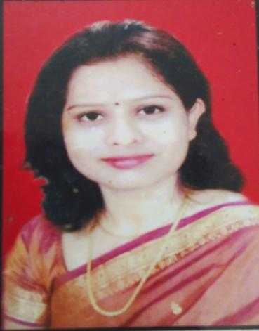

- Department:
INFORMATION TECHNOLOGY
- Institute:
Vasantdada Patil Pratisthan’s College of Engineering & Visual Arts
- Location:
Sion - Mumbai-22
- Email Address:
neetaingale@pvppcoe.ac.in

Personal Profile
Introduction
She works as an Assistant Professor in the Department of Information Technology. Her qualification is Masters of Engineering in EXTC Engineering Department and Bachelors of Engineering in EXTC Engineering. She has 16 years of teaching experience. She has published around 15 papers in both national and international journals. She has guided around 30 projects to Undergraduate Students. She is expertise in the subjects like Principles of Communication, Microprocessor, Mobile Communication, Satellite Communication etc. She is an excellent teacher, enthusiastic and committed towards the works assigned with dynamic leadership quality.

Education
- Master of Engineering (M.E.) in EXTC, Mumbai University.
- Bachelor of Engineering (B.E.) in EXTC, Pune University.

Professional Experience
- Vasantdada Patil Pratishthan’s College of Engineering & Visual Arts, Assistant Professor Since 2015-till date.
- MPPM Padmbhushan Vasantdada Patil Pratishthan’s College of Engineering, Lecturer, 2007-2015.

Courses/ Subject Teaching
- Principles of Communication
- Microprocessor
- Computer Organization and Architecture
- Digital Techniques and Logic design
- Electronics Devices and Circuits
- Mobile Communication
- Satellite Communication
- Electronic Measurement and Instruments
- Optical Fiber Communication

STTP/ FDP/ Research Publications

- FDP on "Virtual and Augmented Reality for Robotics"
from 2021-7-12 to 2021-7-16 at Vimal Jyothi Engineering College.
- FDP on"Research Paper Writing & Publication "on 5th September 2020, organized by Electronics & Telecommunication department, Vasantdada Patil Pratishthan’s College of Engineering & Visual Arts.
- Faculty Orientation program on 7th July 2020 by department of Information technology ,Terna Engineering College, Nerul.
- Webinar on IOT & Nodemcu introduction organized by EXTC Department of PVPPCOE on 25th June 2020.
- “Image enchantment for surveillance videos using quick browsing system “ Paper Presented in International Conference held on 8th&9thApril 2022 at VPPCOE & VA .
FDP from 2022-06-27 to 2022-07-02 on PHP and MySQL organized by VPPCOE & VA.
- STTP on Microwave Engineering held at Xavier Institute of technology On 20th& 21st Jan 2012.
- Paper Presented in International Conference held on 10th& 11th Aug 2012 at P.V.P.P College of Engineering.
- Paper Presented in National Conference held on 10th& 11th Aug2012 at Manohar Phalke Polytechnic.
- IETE approved STTP on “Basic and recent trends in electronic based laboratories” held at PVPP’S College of Engineering On 28th to 30 th June 2015.
- STTP on Network analysis held at PVPP’S College of Engineering On 15th to 26 th June 2015.
- Paper Presented in International Conference held on 26th& 27th Oct 2017 at P.V.P.P College of Engineering.

