Mr.Kiran Deshmukh
Assistant Professor at Vasantdada Patil Pratishthan’s College of Engineering & Visual Arts

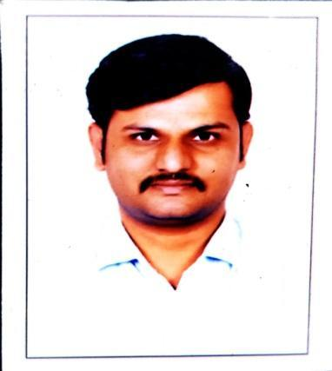

Department:
Information Technology Department

Institute:
Vasantdada Patil Pratisthan’s College of Engineering & Visual Arts

Location:
Sion, Mumbai-22

Email Address:
kdeshmukh@pvppcoe.ac.in

Personal Profile Introduction
He works as an assistant professor in the Department of Information Technology. He has contributed herself in the teaching profession for the last 6 years. He works hard for the betterment of students' educational career.He has good communication, interpersonal skills & subject knowledge.

He has completed a Masters in engineering in Computer Engineering. He has done Bachelors of Engineering in Computer Engineering. He work as a TPO coordinator from Information Trchnology. He was appointed as a “Exam Coordinator (IT Dept)''.

He has taught the subject “Internet of Everything” for final year students, “Internet Programming” for third year students and “Java programming” for second year students. He has subject interests are Machine Learning and Internet of Everything. He has coding knowledge for the languages C, C++, Java, Python and Android technology. He has published 3 paper in various journals and publication, 5 paper with students in the International Conference.

Education
- Master in Engineering (ME) in Computer Engineering, Mumbai University.
- Bachelor of Engineering (B.E.) in Computer Engineering, Dr.BAMU University, Aurangabad.

Professional Experience
- Vasantdada Patil Pratishthan’s College of Engineering & Visual Arts, Assistant Professor from Academic Year 2017-18 (present).
- NJBSPM’s Shantiniketan Polytechnic ,New Panvel , Lecturer, Academic Year 2012-2017.

Courses/ Subject Teaching
- Internet Of Everything (Final Year Information Technology)
- Cloud Computing & Services (Final Year Information Technology)
- Mobile Computing (Final Year Information Technology)
- Software Testing and quality Assurance (Final Year Information Technology)
- Internet Programming (Third Year Information Technology)
- Java Programming (Second Year Information Technology)

Research Specialization
- Internet of Things
- Machine Learning

STTP/ FDP
- She has attended various STTPs, FDPs, Courses and been awarded with Certificates.
- These are listed as follows,

S. N | STTP/ FDP/ Course Name | STTP/ FDP/  Course/ etc. | Start Date | End Date | No. of Days | Organization
1 | Integrating Research Methodology Tools,Computer Vision & Natural Language Processing | STTP | 23 Dec 2020 | 28 Dec 2020 | 6 | Padmabhushan Vasantdada Patil Pratishthan’s College of Engineering, Mumbai
2 | Innovative trends in engineering and technology | FDP | 25 May - 2020 | 29 May 2020 | 3 | Shree L.R.Tiwari collge of Engineering
3 | Data Science with Python | FDP | 18 May2020 | 22 May2020 | 5 | Terna Engineering College, Nerul
4 | R Programming | FDP | 27 April  2020 | 02 May  2020 | 6 | Padmabhushan Vasantdada Patil Pratishthan's College of Engineering, Mumbai (Spoken Tutorial Project, IIT Bombay)
5 | Android app using Kotlin | FDP | 5 July  2021 | 10 July  2021 | 5 | Padmabhushan Vasantdada Patil Pratishthan's College of Engineering, Mumbai (Spoken Tutorial Project, IIT Bombay)
6 | Emerging Trends in Data Science and Data Security | STTP | 2 nd January – 7 th January 2023 | 7 th January 2023 | 5 | Vasantdada Patil Pratishthan’s College of Engineering & Visual Arts, Mumbai
7 | PHP and Mysql | FDP | 27 June 2022 | 2 July 2022 | 6 | IIT Bombay

Research Publications

- Mr. Kiran Deshmukh has published the paper Football Pitch Analysis in 7th International Conference ICIRTE-2022 in Association with Elsevier SSRN.
- . An efficient packet routing mechanism in wireless mobile networks using DCIM 2014; Volume 2 (8): 132-137 ISSN: 2319-507X.
- A paper on “Distrubuted Cache Invalidation Method For Packet Routing Mechanism in Wireless Network”, 2019, in International Journal of Emerging Technologies and Innovative Research ISSN:2349-5162, Vol.6, Issue 3.
- ‘Algorithm Visualization’ Volume:04/Issue:04/April-2022,Impact Factor-6.752 ,e-ISSN:2582-5208 .published in irjmets
- “Covid -19 Pandemic Analysis using Machine learning “Volume:04/Issue:04/April-2022,Impact Factor-6.752 ,e-ISSN:2582-5208 .published in irjmets.

