Ms. Mayuri Tejas Karnik
Assistant Professor at Vasantdada Patil Pratishthan’s College of Engineering & Visual Arts
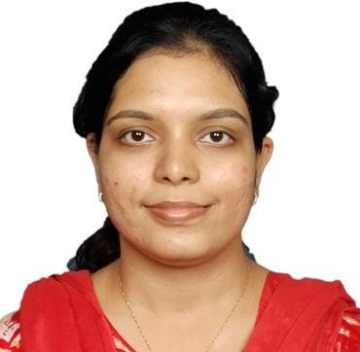

Department:
Information Technology

Institute:
Vasantdada Patil Pratisthan’s College of Engineering & Visual Arts

Location:
Sion, Mumbai-22

Email Address:
mayuri.tharval@pvppcoe.ac.in

Personal Profile
Introduction
She grew up among teachers family. Thus, it was but natural to develop an inclination towards teaching and the curiosity to learn new things. Education is all about holistic development and being open minded to observe and create new things.
Teaching has always been her passion which made us understand clearly her career path. Following her passion she joined college as a Lecturer after completing BE course.
Taught various subjects in 6 years of teaching experience namely Web Programming, Java, Computer Simulation and Modelling, Project Management, Python, Database Management System and so on. She strongly believes in

the quote, “Teaching is a continuous process of learning,” which has been followed from the starting of her career and is busy in reading new subjects and research about new domains like IoT and Internet Programming. Also been a mentor and guided many students in academic sessions for their Mini Project work, domain work and much more.

Education
- Master of Engineering (M.E.) in Information Technology, Mumbai University.
- Bachelor of Engineering (B.E.) in Information Technology, Mumbai University.

Professional Experience
- Vasantdada Patil Pratishthan’s College of Engineering & Visual Arts, Assistant Professor from Academic Year 2021-22 to Present.
- Vasantdada Patil Pratishthan’s College of Engineering & Visual Arts, Assistant Professor, Academic Year 2018-19.
- Vasantdada Patil Pratishthan’s College of Engineering & Visual Arts, Assistant Professor, Academic Year 2016-17.
- Vasantdada Patil Pratishthan’s College of Engineering & Visual Arts, Assistant Professor, Academic Year 2013-14 to 2014 – 2015.

Courses/ Subject Teaching
- Java Lab (SE IT)
- Cyber Security and Laws (BE IT)
- Internet Programming (TE IT)
- Java Programming (Expert Talk, Placement Activity)
- Web X.0 (TE IT)

Research Specialization
- Internet of Things
- Internet Programming

STTP/ FDP
- She has attended various STTPs, FDPs, Courses and been awarded with Certificates.

- These are listed as follows:

Academic Year 2021-22
S. N | STTP/ FDP/ Course Name |  |  |  | STTP/ FDP/  Course/ etc. | Star t Dat e | En d Dat e | No. of Days | Organization
1 | Cyber Hacking | Security | and | Ethical | Program | 10 Jan  2022 | 15 Jan  2022 | 6 | Xavier Institute of Engineering, Mahim
2 | Web X.0 |  |  |  | FDP | 03 Jan  2022 | 08 Jan  2022 | 6 | Xavier Institute Engineering, Mahim | of

