Mr. Nilesh Mali
Assistant Professor at Vasantdada Patil Pratishthan’s College of Engineering & Visual Arts
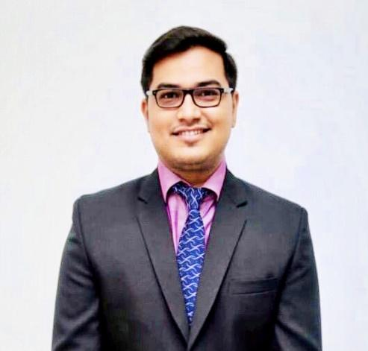
- Department:
Information Technology
- Institute:
Vasantdada Patil Pratisthan’s College of Engineering & Visual Arts
- Location:
Sion, Mumbai-22
- Email Address:
nileshmali@pvppcoe.ac.in

Personal Profile

Introduction
Mr. Nilesh Mali is currently working as an Assistant Professor in the Department of Information Technology. He has contributed himself in the teaching profession for more than 10 years. His teaching style is student-centered and interactive. Being a teacher is unbiased and loyal. He had chosen this profession for the betterment of the institute. He works hard for the betterment of students' educational career. He is very dedicated towards his work. He has good communication, interpersonal skills & subject knowledge.

Education
- Master of Engineering (M.E.) in Computer Engineering, Mumbai University.
- Bachelor of Engineering (B.E.) in Computer Engineering, Pune University.

Professional Experience
- Vasantdada Patil Pratishthan’s College of Engineering & Visual Arts, Assistant Professor from 11th July 2022 to till date.
- Bunts Sangha’s Higher Education Institutions, Assistant Professor from 9th November 2017 to 9th July 2022.
- Vivekanand Education Society's Institute of Technology, Assistant Professor, 10th July 2017 to 8th November 2017.
- Alamuri Ratnamala Institute of Engineering & Technology from 19th August 2014 to 8th July 2017.

Courses/ Subject Teaching
- Internet Programming
- Automata Theory
- Data Structure and Analysis
- Database Management System

STTP/ FDP/
- Attended One Week AICTE-ISTE approved STTP on “Emerging trends in Data Science and Data Security” during 2nd to 7th Jan, 2023.

- Attended a One Week FDP on “Intellectual Property Rights” during 20th to 26th April, 2020.

- Attended a One Week FDP on “Java Business Application” during 29th April to 5th May, 2020.

- Attended a One Week FDP on “Insight into Quality Research and Innovation” during 13th to 20th May, 2020.

- Attended a One Week FDP on “Machine Learning and Applications” during 18th to 23rd May, 2020.

- Attended a National level STTP on “Latest Technologies in Computer Education” during 6th to 8th Aug. 2016.

Research Publications
- Published paper entitled “Forensic Face Sketch Construction and Recognization” in International Journal of Research and Analytical Reviews (IJRAR) of Volume 10, Issue 2, E-ISSN 2348-1269, P- ISSN 2349-5138, pp. 779-781, April 2023.

- Published paper entitled “Analysis and Predicting the Spreading Rate of COVID-19 in India” in Modern Thamizh Research, ISSN: 2321-984X, 30th April 2021.

- Published paper entitled “Data Center with Green Cloud Computing: A Way to Manage Servers” in Ajanta,Volume-VIII, Issue-I, ISSN: 2277-5730.

- Published paper entitled “A Recommender System Using Data Stored In Heterogeneous Database” in International Journal of Latest Trends in Engineering and Technology e-ISSN: 2278-621X, Vol. 8 Issue 1, pp.380-384, Jan 2017.

- Published paper entitled “A Survey of ETL Tools” in International Journal of Computer Techniques - ISSN: 2394-2231, Volume 2 Issue 5, pp. 20-27, Sep – Oct 2015.

- Published paper entitled “New Emerging Trends in education systems using flexibility and 24x7 learning with paperless examination” in CENTUM, ISSN: 2231-1475, pp. 208-211, Aug 2014.

