Industrial Visit/Field Visit
An Informative Event Attended at IIG
An Industrial Visit (IV) was organized by Humanities and Basic Science Department of Padmabhushan Vasant Dada Patil Pratishthan’s College of Engineering (PVPPCOE) at Indian Institute of Geomagnetism (IIG). Panvel on 15th Oct. 2019 between 9:30 am and 4:00 pm as a part of Induction program. 168 students of PVPPCOE reported at IIG, along with teachers of first year. Several college along with the PVPPCOE, from the vicinity participated.
The event began with an informative seminar which was portraying all the relevant concept of geomagnetism. Advanced audio-visual techniques were used in the seminar to enlighten all the significant points related to geomagnetism and astronomy. Satisfactory answers were given to all the queries raised by students
After the seminar, the event continued with the wonderful prospects, posters all exhibiting innovative and novel ideas for the projects and posters also highlighted and covered all the essential points related to global positioning system (GPS) evil consequences of harmful radiations emitted by the sun and many more.
After the poster presentations, there was exciting quiz competition college students. Enthusiastic participation was observed from the PVPPCOE students. The PVPPCOE students won 1st Prize in Quiz; There was a sense of jubilation amongst the students. The cheering and applause took minutes to abate. It was indeed a proud moment for PVPP. The winners of the quiz were given complimentary books authored by eminent personalities. Every participant was given a certificate as a token of appreciation.
“The Industrial visit was found to be very fruitful.

Mrs Neeta Vanage
Mrs Vibhavari Kulkarni
Coordinator

Dr Namdev More
HOD, HBS
Photo Gallery
15 October 2019

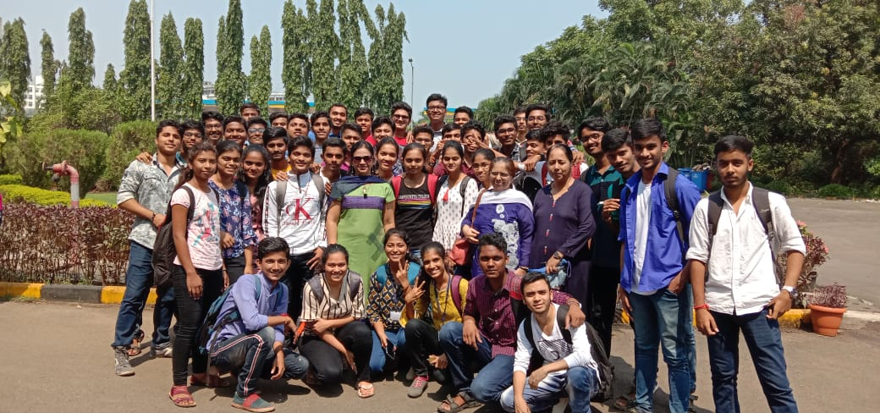

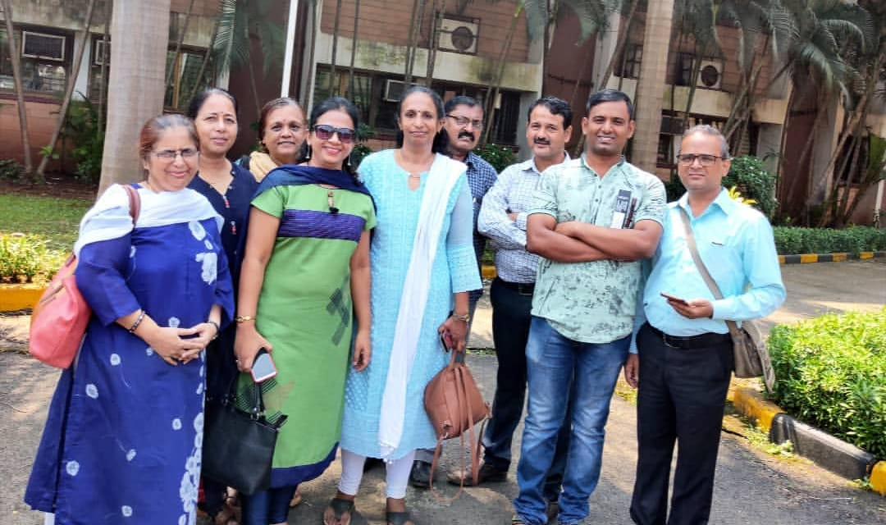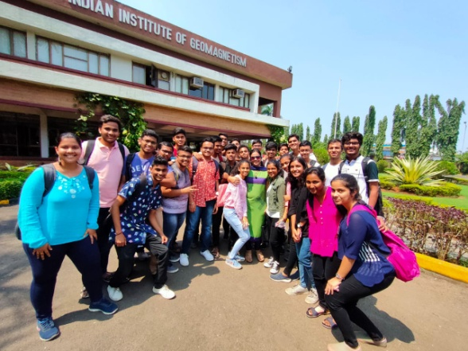
H&BS Teachers at IIGM Students in great cheer

Winners of the quiz Competition- receiving prize from IIGM Stalwarts

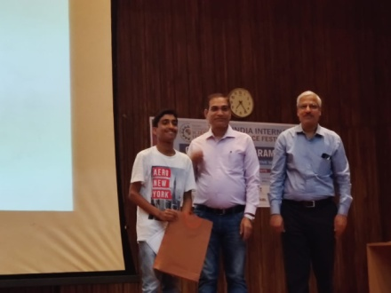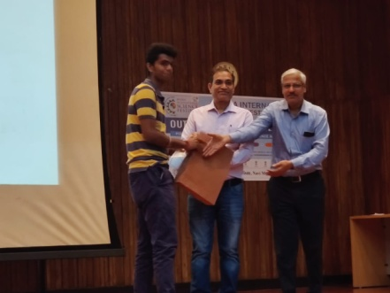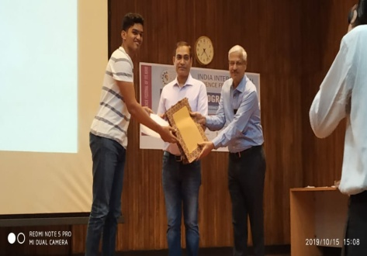
Samruddha Somani Manas Phadke Abhishek Walavalkar

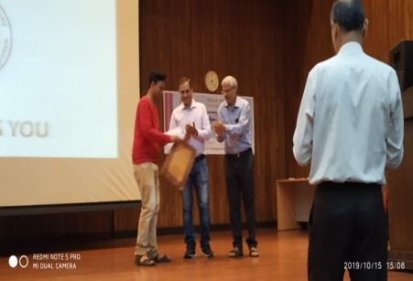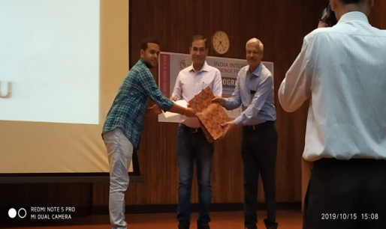
Rushil Sawant Kautilya Singh

