REPORT ON STUDENT INDUCTION PROGRAM-2019-20
(09/08/2019-19/08/2019)

In accordance with AICTE new model curriculum, Humanities and Basic Science Department of Padmabhushan Vasantdada Patil Pratishthan’s College of Engineering, conducted a week long induction program for first year students of 4-year BE degree course (Academic year 2019-20) from 7th August 2019 to 14th August 2019.The program was well designed, informative and educative first of its kind to groom and nurture young engineering students to mould student fraternity in the days to come. Total 248 entrants from Computer, Information Technology and Electronics and Telecommunication engineering participated enthusiastically and obtained benefit from the program.
The aim of the program was to give the students who are joining the college a bird’s eye view about various dimensions of engineering and the career opportunities for the engineering students and to acquaint them with the systems and procedures of the college, as also to give them an idea about anti ragging laws so as to have an ease in their transition to the core engineering program. They were enlightened about the prospective scope of the arena that they had opted for their success. The college committee for Induction programme invited experts from different leading industries and esteemed institutions to interact with the entrants and brief the learners with their expertise in various fields. Along with expert talks, the committee also planned village visit and industrial visits in the semester for catering their social as well as technical side of learning. The idea of such a programme came from the thought that one of the reasons for the disorientation of engineering students is sheer ignorance about their opportunities and the direction they have to move so as to become successful as engineers.

Day 1.
Day 1 of Induction program started with orientation of new entrants and also welcome to students and their parents. The program witnessed huge attendees comprising parents and students. Around 247 students and 320 parents attended enthusiastically .The program started with the blessings of goddess Saraswati and our founder members Late Vasantdada Patil and Late Manohar mama Phalke. Sr.Adv.Shri. Appasaheb Desai, General Secretary PVPPCOE and Dr. Alam Shaikh Principal, PVPPCOE graced the program and extended their greetings to the parents and encouraged the new entrants.On behalf of management, Shri. Appasaheb Desai and on behalf of the institute Principal Dr Alam Shaikh addressed the parents and motivated the students. Dr. Namdev More, HOD gave brief presentation on the culture of the institute and functioning of the Department. The queries of parents and students were attended. The institute was overwhelmed by the positive feedback given by the parents. The program was concluded with the Vote of thanks followed by National Anthem. Refreshments were arranged for all the attendees. The orientation was followed by a small address by NGO catalyst ,a initiative to help and groom girl student.
All the department heads took charge of the afternoon session. HOD of respective department briefed the students about the future scope of the branch, the student has opted for. They familiarized and acquainted the students with various laboratories and facilities of their department. The student council took the students for college tour showing various common facilities like Girls and boys common room, Gymkhana. Library, canteen, playground, NSS room, incubation centre, Computer centre, etc .
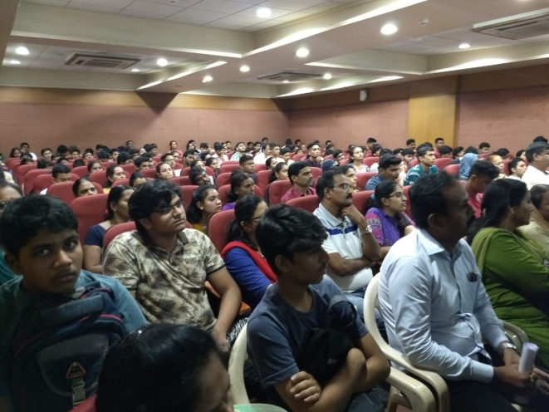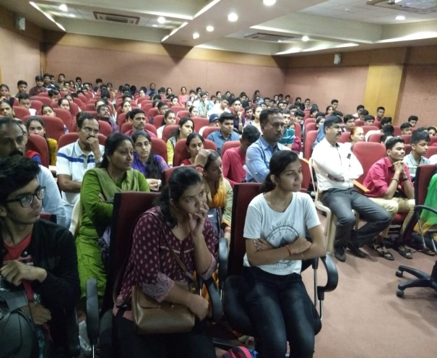
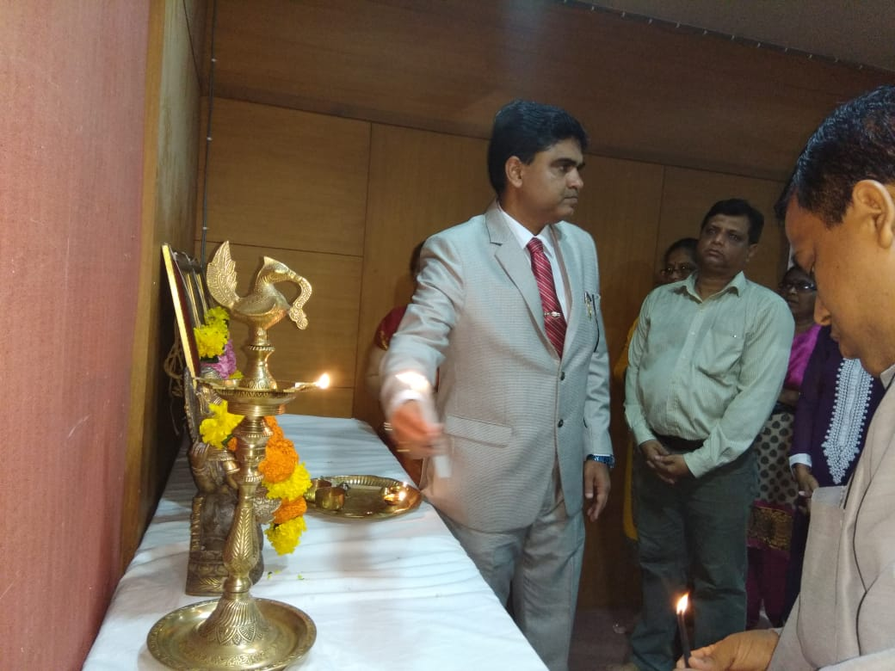
Day 2.
Morning session:
Stress, now a days is an integral part of every human and to tackle it is the biggest challenge. Very effective seminar on ‘TURN STRESS INTO SMILE-STRESS MANAGEMENT” was arranged in association with ISKON. Mr Ishan Gaur and Mr Jhanudvip Nitai of ISKON enlightened the students with different aspects of it and gave a deep insight human values which will help students imbibe strong cultural and moral values.
Afternoon Session:
The pressures of a highly demanding curriculum can get to even the best of students. Along with the academics, college provides an exciting and stimulating environment filled with fun and relaxation. The cosmopolitan environment provides opportunities to appreciate and understand other cultures and languages. There are several Clubs and Associations formed in the college in view of overall development of students. The student council gave a brief idea of all the 12 student clubs like adventure club, fine art, astronomy, etc. Mr Nilesh Nagrale, NSS head brief them about NSS activities undertaken in the college and Antarishk Patil told about Debate club and Eco club. Mr Ronak Mehta, Alumni of IT department, guided the students for entrepreneurship.

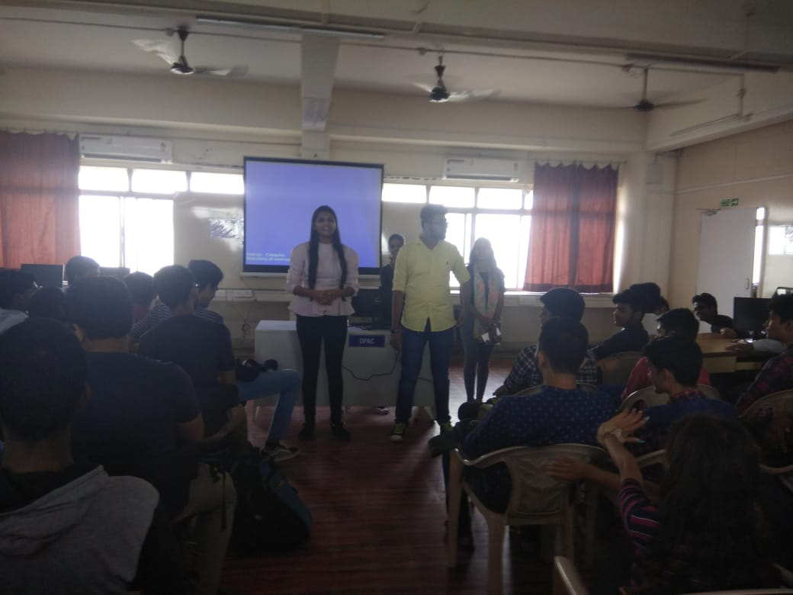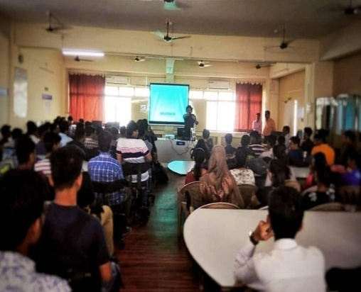
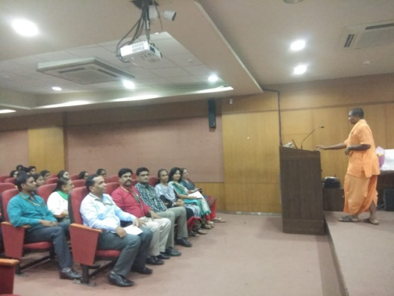
Day 3:

Morning Session:
The session started with the Mentor allocation to students. For effective mentoring and for the welfare of students group of 20 students were assigned to a faculty mentor. Along with the faculty mentor, for every 10 students a senior student mentor was also assigned. The mentoring system is adopted to improve the rapport between the faculty and students. The mentoring sessions primarily focus on academic improvement by monitoring progress on regular basis. This session was followed by Subject orientation to the students. The concerned faculty gave the clear and in-depth information, marking scheme, practical list etc of their respective subjects. Aforementioned span was allotted to the subject teachers to interact with the entrants in classroom lectures. The concentration of Subject Proficiency Sessions was to revise seminal concepts and treat the gap of knowledge in order to brush up and rectify conceptual understanding of the subjects which were studied at their school level. This was followed by introduction to the subjects of First-Semester engineering curriculum and discussion to enrich student’s knowledge of subject-specific terminology. Subject Proficiency Sessions not only offered students basic understanding of the subject to be studied at First-Semester but also it aided them to build rapport with their teacher which in turn would serve the smooth escalation to the core engineering studies.

Afternoon session:
The diagnostic test was conducted for every subject to bridge the gap between the concepts the students had learned in plus two levels (XII Std) and the current engineering syllabus. 20 Multiple choice questions for each subject were framed to assess the conceptual understanding and logical thinking of the students.
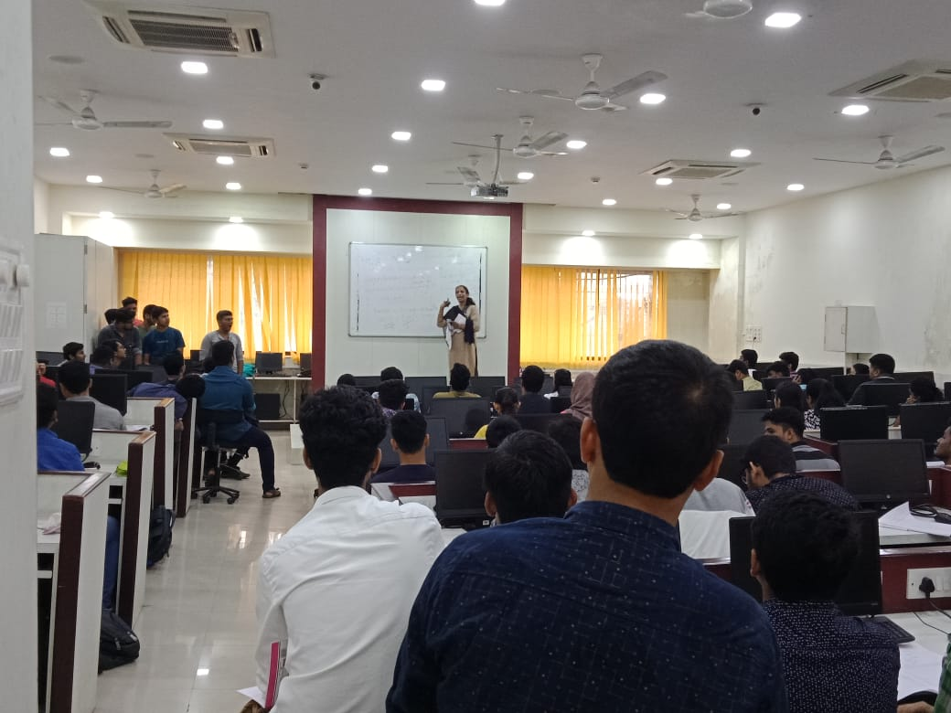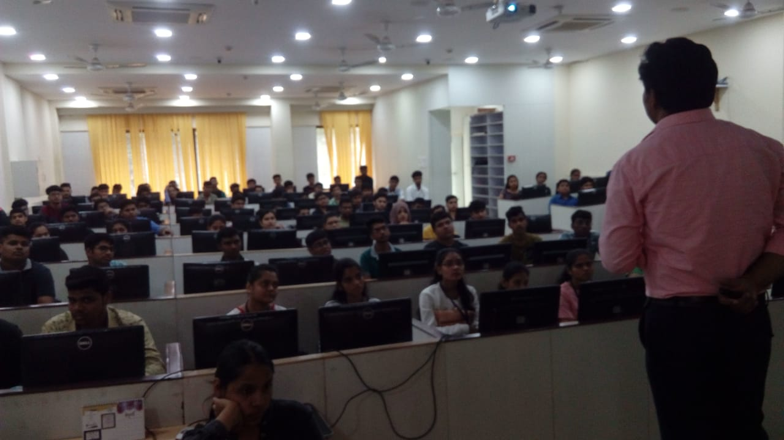

Day 4:Morning Session:
The English Proficiency module was specially designed for entrants to enhance their technical vocabulary and general and technical communication skills. Being able to communicate effectively is one of the most important life skills. Communication skills, soft skills, Interpersonal skills are the skills required to effectively communicate, interact, and work with individuals and groups. To be able to communicate effectively -is the need of an hour. Needless to say, English Proficiency plays a vital role in the academic and professional life of a person. Candidate proficient in English enjoys more accolades at both the grounds. Mr Hussain Sabuwala , a professional trainer and speaker, delivered an exceptionally informative and entertaining lecture for the students.The proficiency module in mathematics and computer programming was arranged to make student understand the basic concepts.
Afternoon Session:
“Healthy Body is the foundation for healthy mind”. Students were motivated and encouraged to play sports like cricket, football dodge ball. This activity increased the bonding between the students. Students enjoyed playing in teams and were actually a stress relieving exercise. 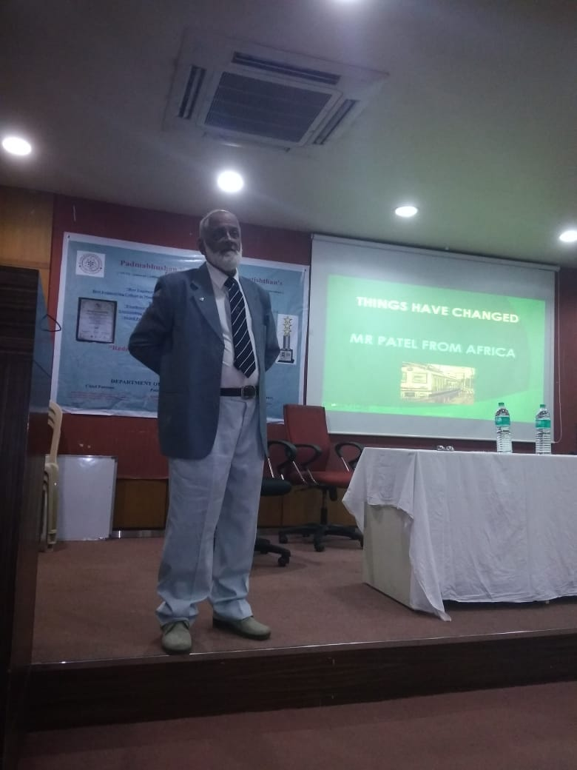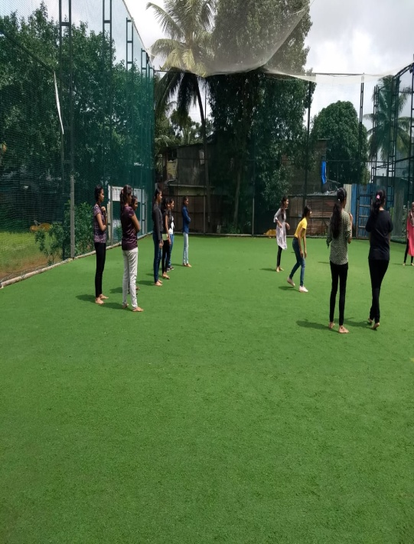

Day 5:Morning session:
Meditation and yoga can contribute directly to improve mental focus and concentration among students. It involves long, deep, slow breathing, as well as the coordination of mental concentration. Yoga combines strength and flexibility exercises with relaxation and meditation. Eminent speaker and a yoga practitioner from “Brahmakumari” were invited to conduct the yoga sessions for students.
Afternoon Session:
Social/cultural activities not only help students to identify themselves with the university, but also assist students to develop themselves in a desired field and also improve skills such as organizational, presentation, leadership and interpersonal communication. Cultural program was executed by the new entrants showcasing their hidden talents. This session was appreciated and enjoyed with extreme zest and enthusiasm.
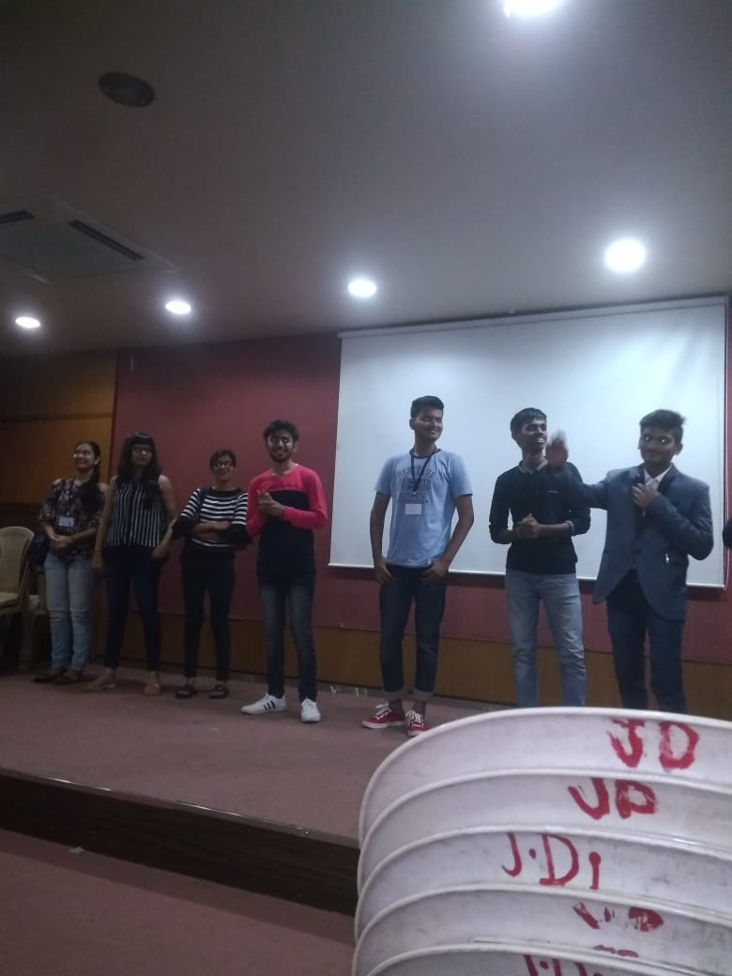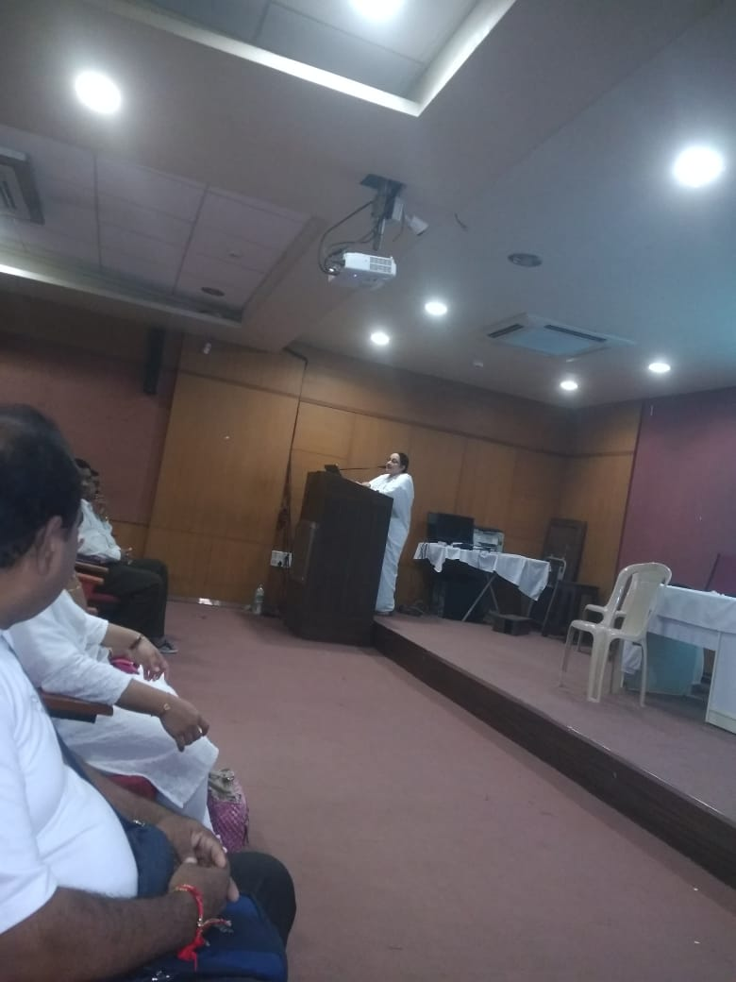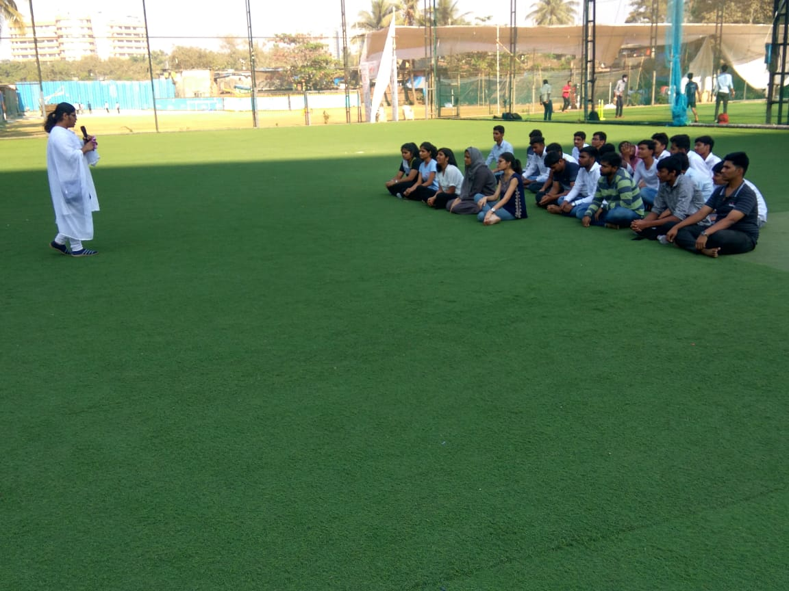
Conclusion:
The entrants, the teachers, and the stakeholders received optimum benefit from the programme. With the fulfillment of the stated objectives, the Induction Programme concluded with great success.

Coordinators: Mrs Neeta Vanage & Mrs Vibhavari Kulkarni
HOD, H&BS: Dr Namdev More

