`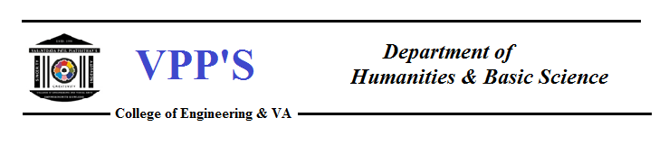
SYNAPSE 2023
Introduction-
SYNAPSE 2023 by FESA was held on 25th May, 2023 organised by the FESA committee in conjunction with the Department of Humanities and Basic Science. Nearly 182 – 190 students actively participated in the FESA. The event was graced with the benevolent presence of the esteemed guests, our respected principal, Dr.Alam Shaikh and the Head of Department of Humanities and Basic Sciences, Dr.A.Y.Shete inspired and motivated the students by their words and extended their blessings and best wishes to the students . Secretary of FESA briefed about the activities to be undertaken by FESA .

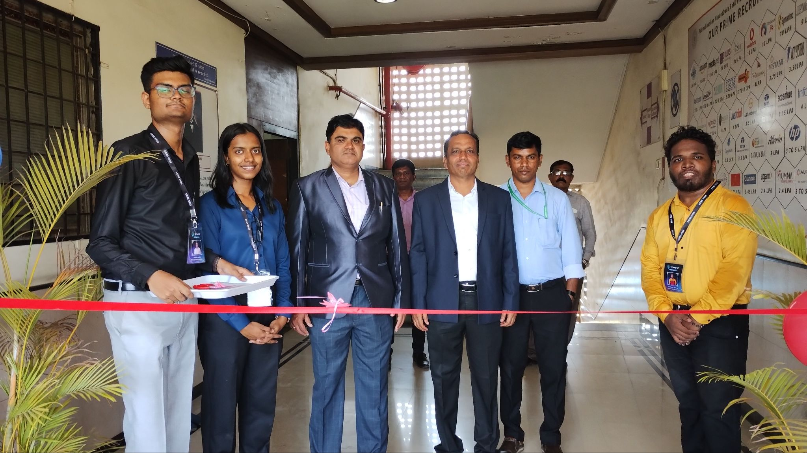
The Inauguration

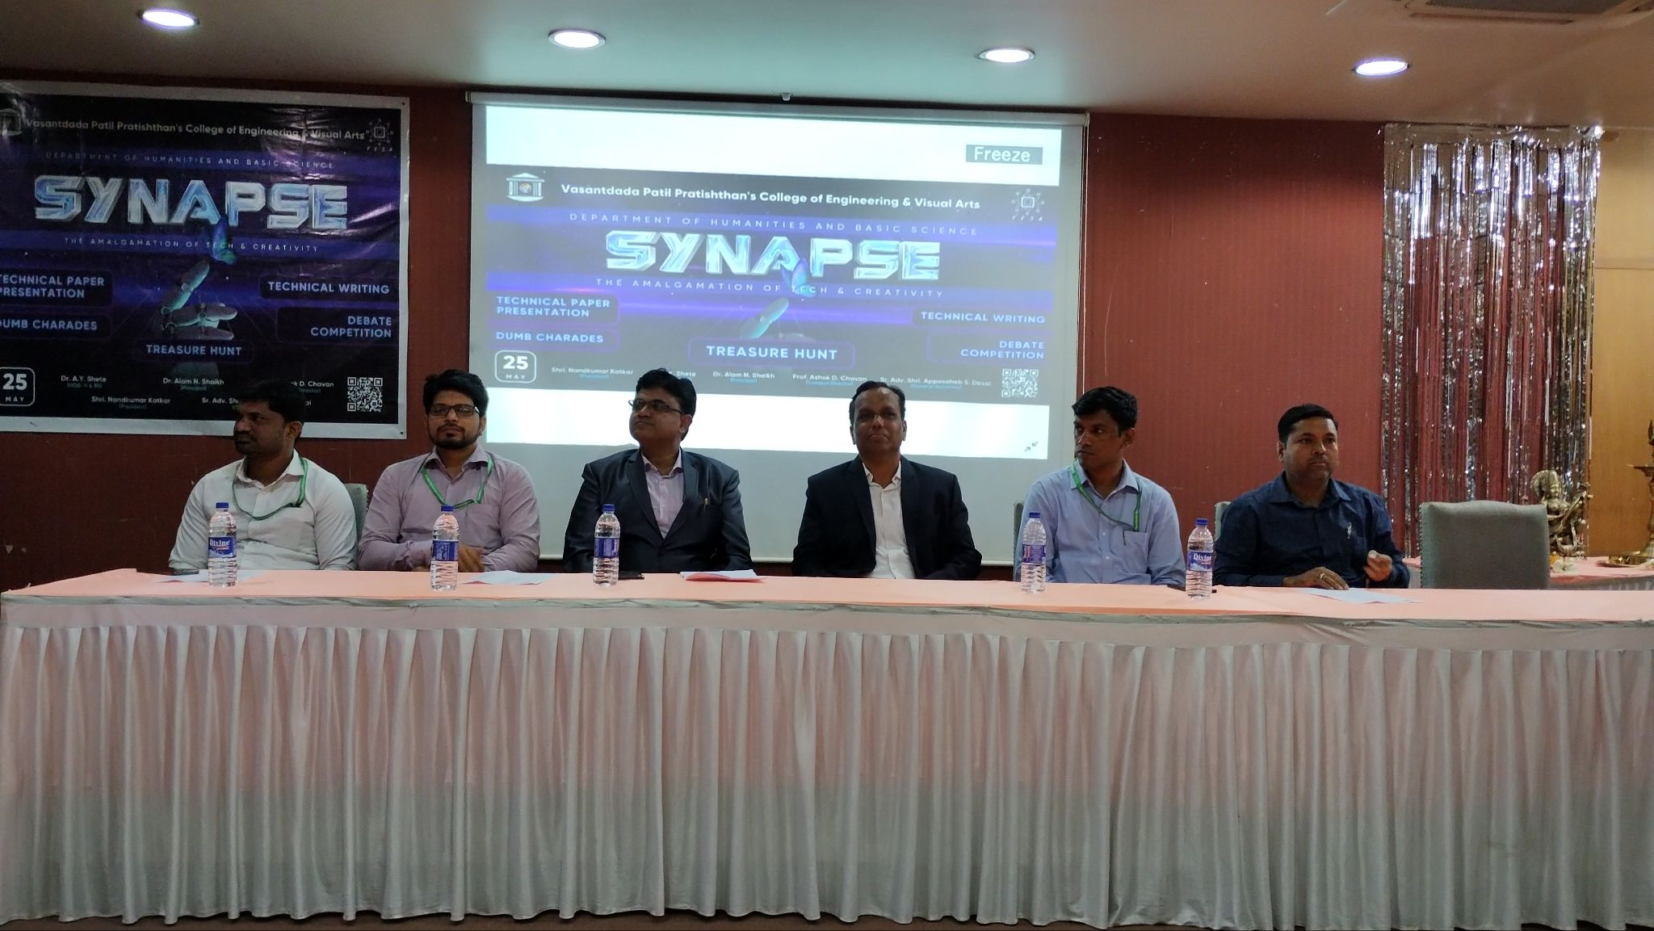
The Dignitaries

Schedule of Synapse 2023
1] 10:00 AM TO 11:00 AM INAUGURATION
2] 10:30 AM TO 11:15 AM TECHNICAL WRITING
3] 11:15 AM TO 11:25 AM BREAK
4] 11:30 AM TO 12:45 PM TECHNICAL PAPER PRESENTATION
5] 12:00 PM TO 1:00 PM DUMB CHARADES
6] 1:00 PM TO 1:30 PM BREAK
7] 1:30 PM TO 2:30 PM DEBATE
8] 2:30 PM TO 3:30 PM TREASURE HUNT
9] 3:45 PM TO 4:45 PM VALEDICTORY FUNCTION
Technical Writing-
Technical writing is any writing designed to explain complex, technical, and specialised information to audiences who may or may not be familiar with them.
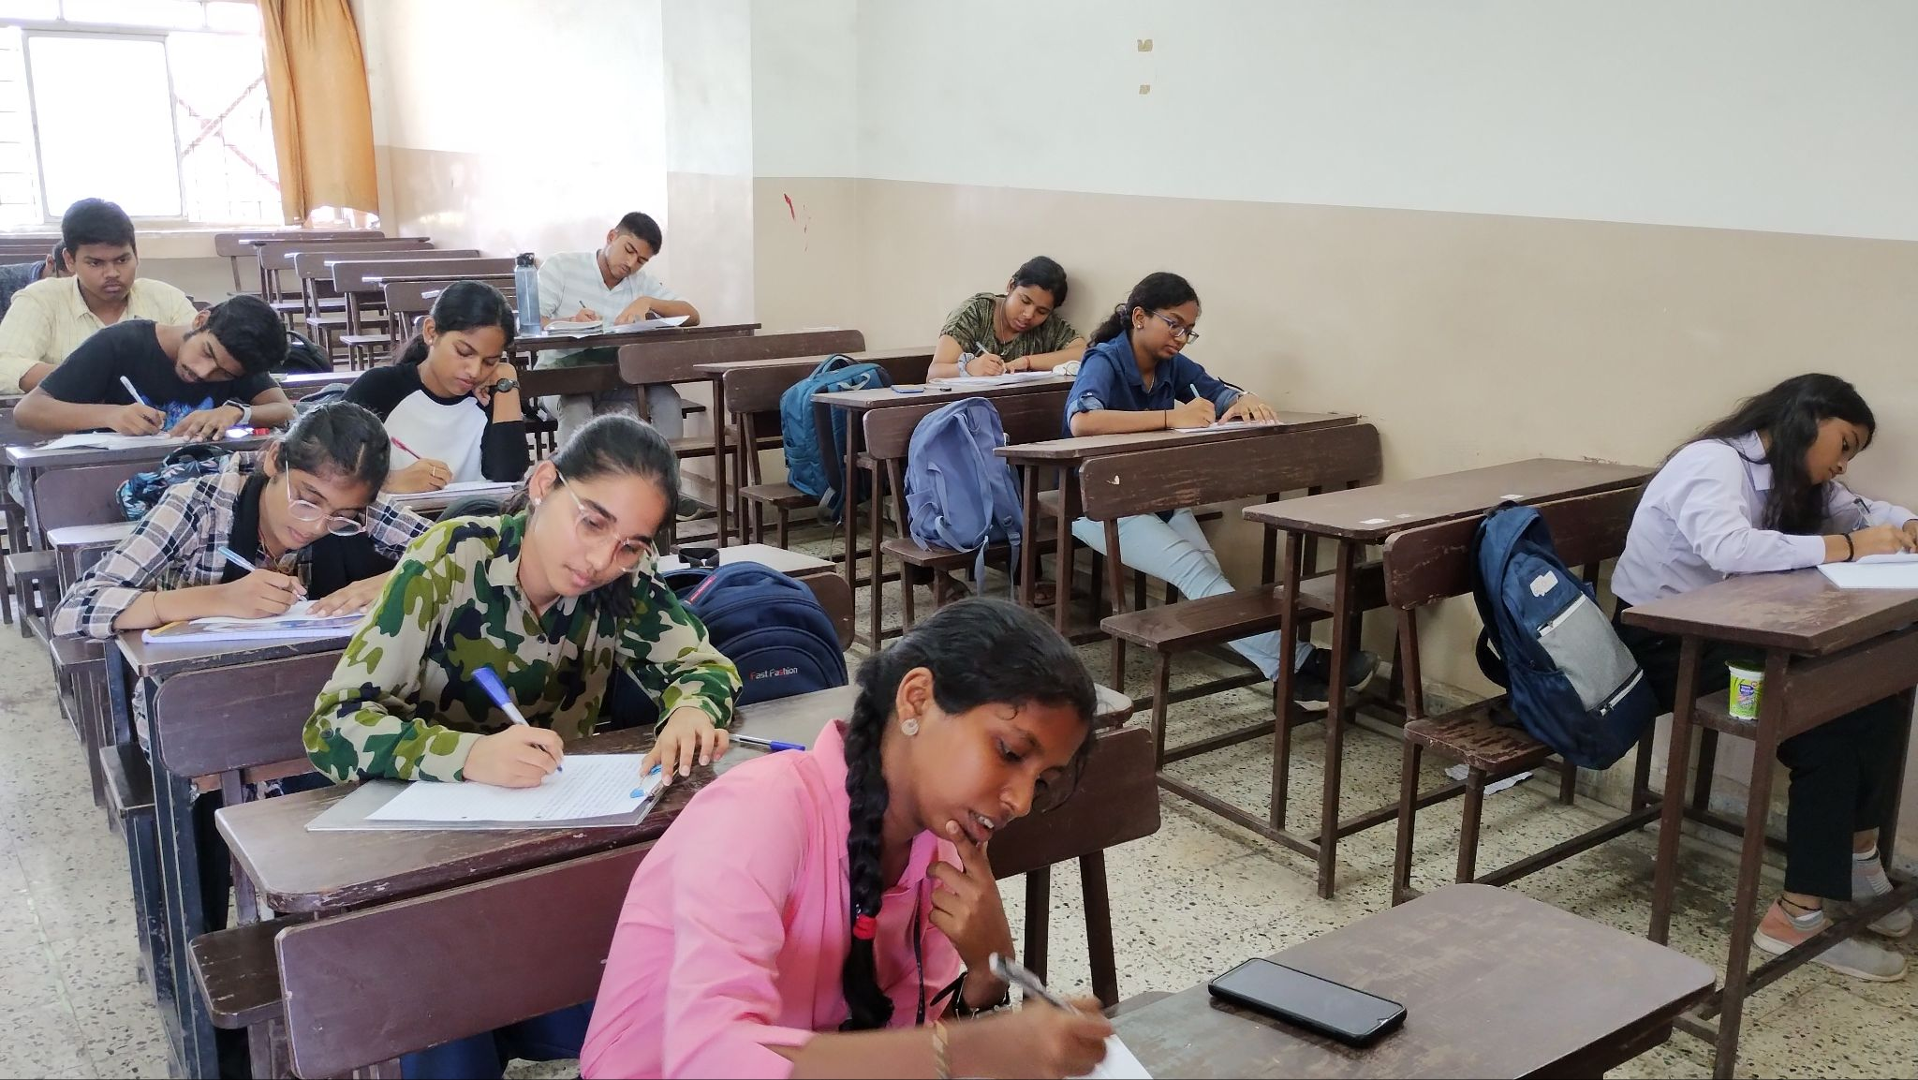

Participants-
- Sairaj Sonawane
- Omkar Ardekar
- Shreya kairamkonda
- Disha Holmukhe
- Swatantra Mahavir Kasliwal
- Prabha Gawde
- Prachi Ganesh Sawant
- Gayatri.Racharla
- Suraksha Patil
- Soham Gawde
- Nashrah Ansari
- Sindhu Suresh Arali
- Yash Soni
- Rohit Adepu
- Dattaram Muknak
- Prithviraj Chavan
- Rishik Bale
- Sumedh Sawant
Winner- Prachi Jadhav
Technical Paper Presentation-
Technical presentations are a specific genre that often take the complex, lengthy information included in a formal report and condenses and translates that information in a way that includes visual and audio communication modes.
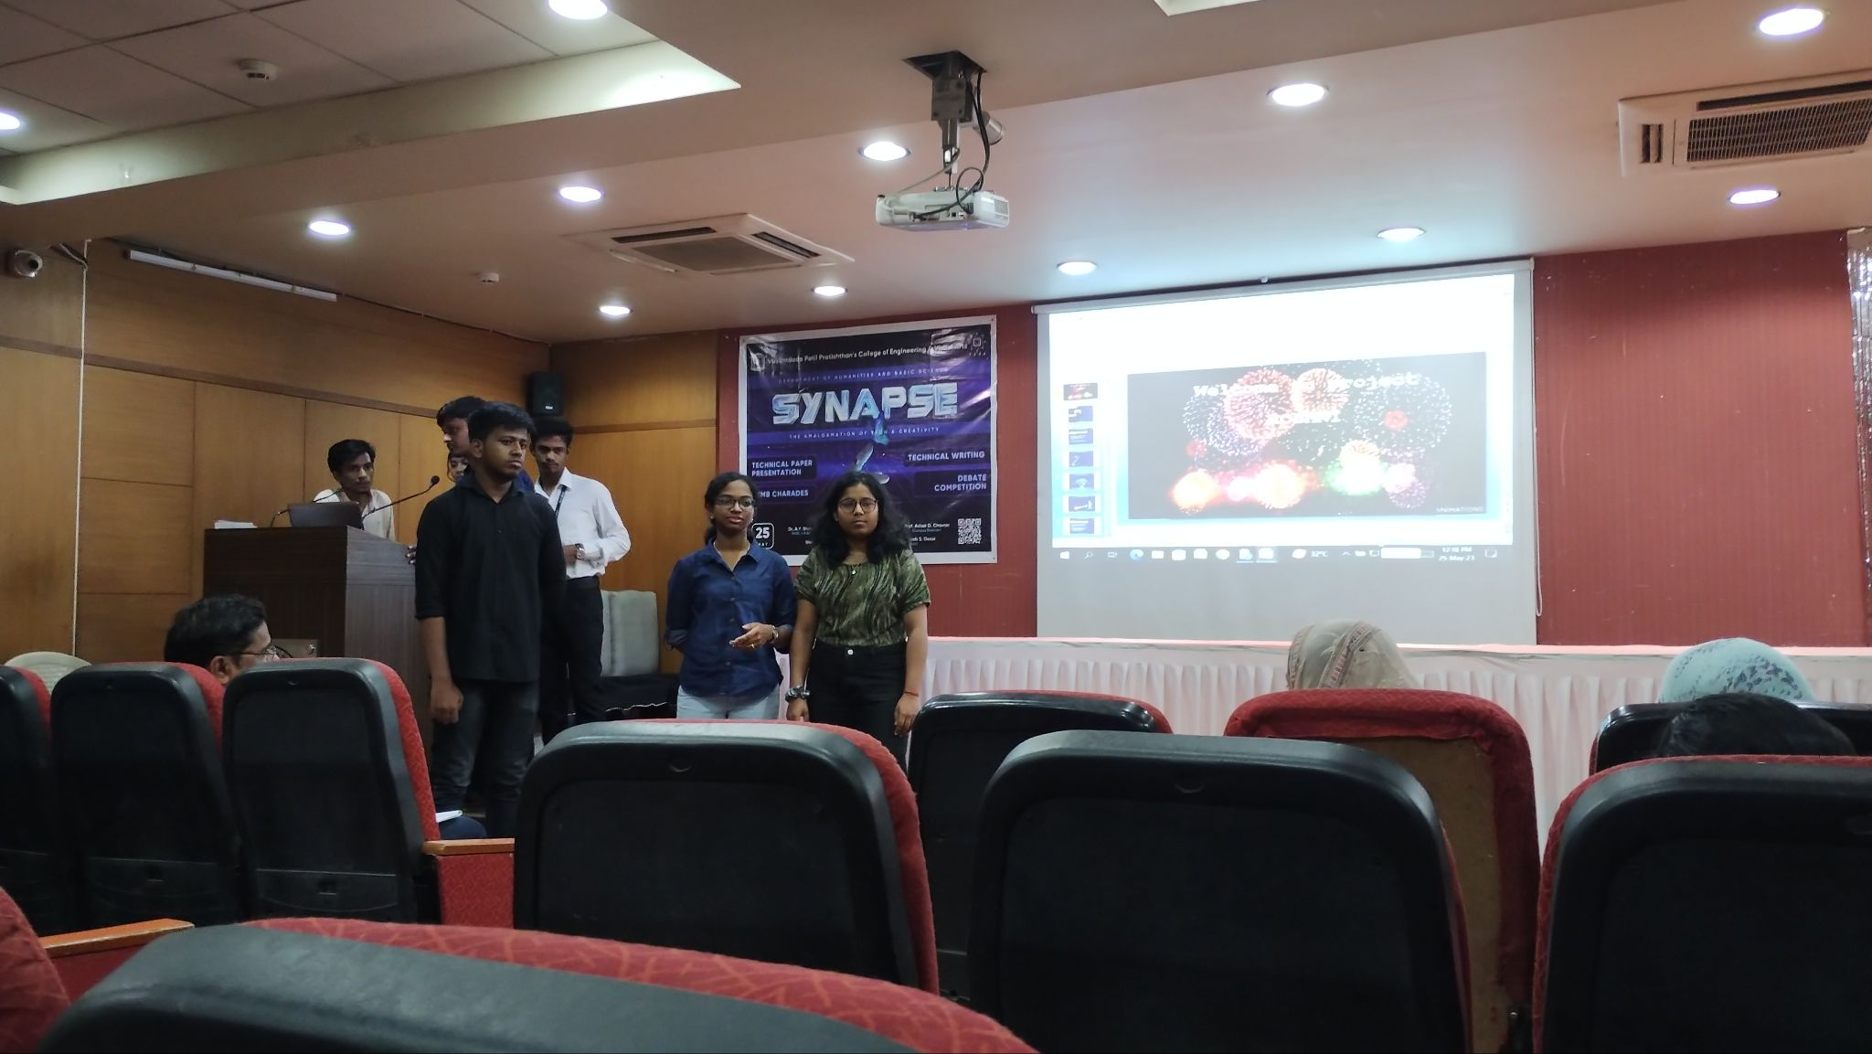

Team Leader | Member 1 | Member 2 | Member 3 | PPT | Presentation | Q&A | Total
Disha Holmukhe | Swatanta Kasliwal |  |  | 9 | 9 | 9 | 27
Shivam Patel | Vijay Sharma | Bhavesh Pathak | Shashank Gupta | 9 | 9 | 9 | 27
Sumedh Sawant | Damini Shrivastava |  |  | 9 | 9 | 8 | 26
Sindhu | Vinayak | Shreya |  | 9 | 7 | 9 | 25
Winner-Disha Holmukhe,Swatanta Kasliwal
Runner ups- Shivam Patel,Vijay Sharma,Bhavesh Pathak,Shashank Gupta

Debate-
Debate is a process that involves formal discourse, discussion, and oral addresses on a particular topic or collection of topics, often including a moderator and an audience.
Topic- Technology is the need of hour even at the cost of the environment
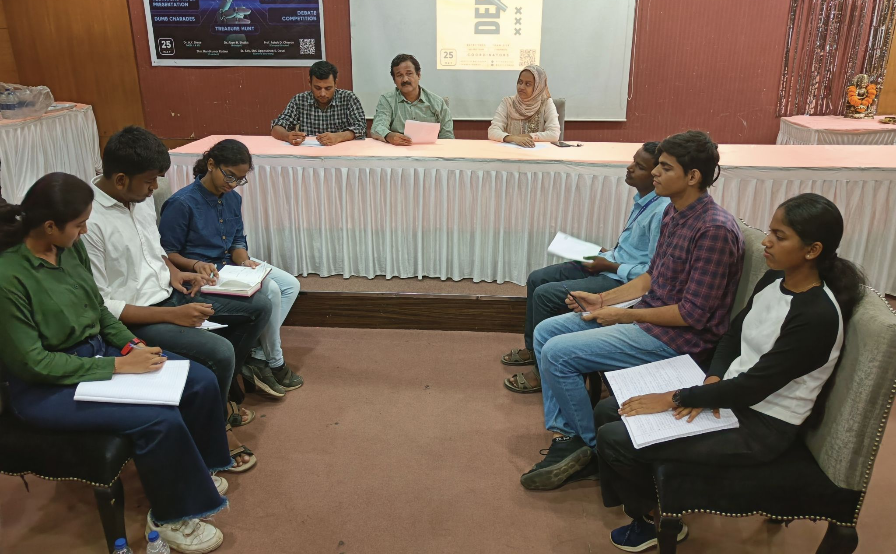

Team Leader’s Name | Member 1 | Member 2 | Introduction | Arguments | Judge | Summary | Total
Prachi Sawant | Vijay Sharma | Shivam Patel | 7 | 6 | 6 | 7 | 26
Vinayak Patil | Shreya KairamkOnda | Apoorva Kadam | 6 | 7 | 6 | 6 | 25

Winner-Prachi Sawant,Vijay Sharma,Shivam Patel
Runner up-Vinayak Patil,Shreya Kairamkonda,Apoorva Kadam

Dumb Charades-
Dumb Charades involves explaining the phrases or the name of the movie, a personality, a book or a TV show, etc. through acting. A person is not allowed to talk and is required to act out the name by using different gestures, facial expressions, and body language.

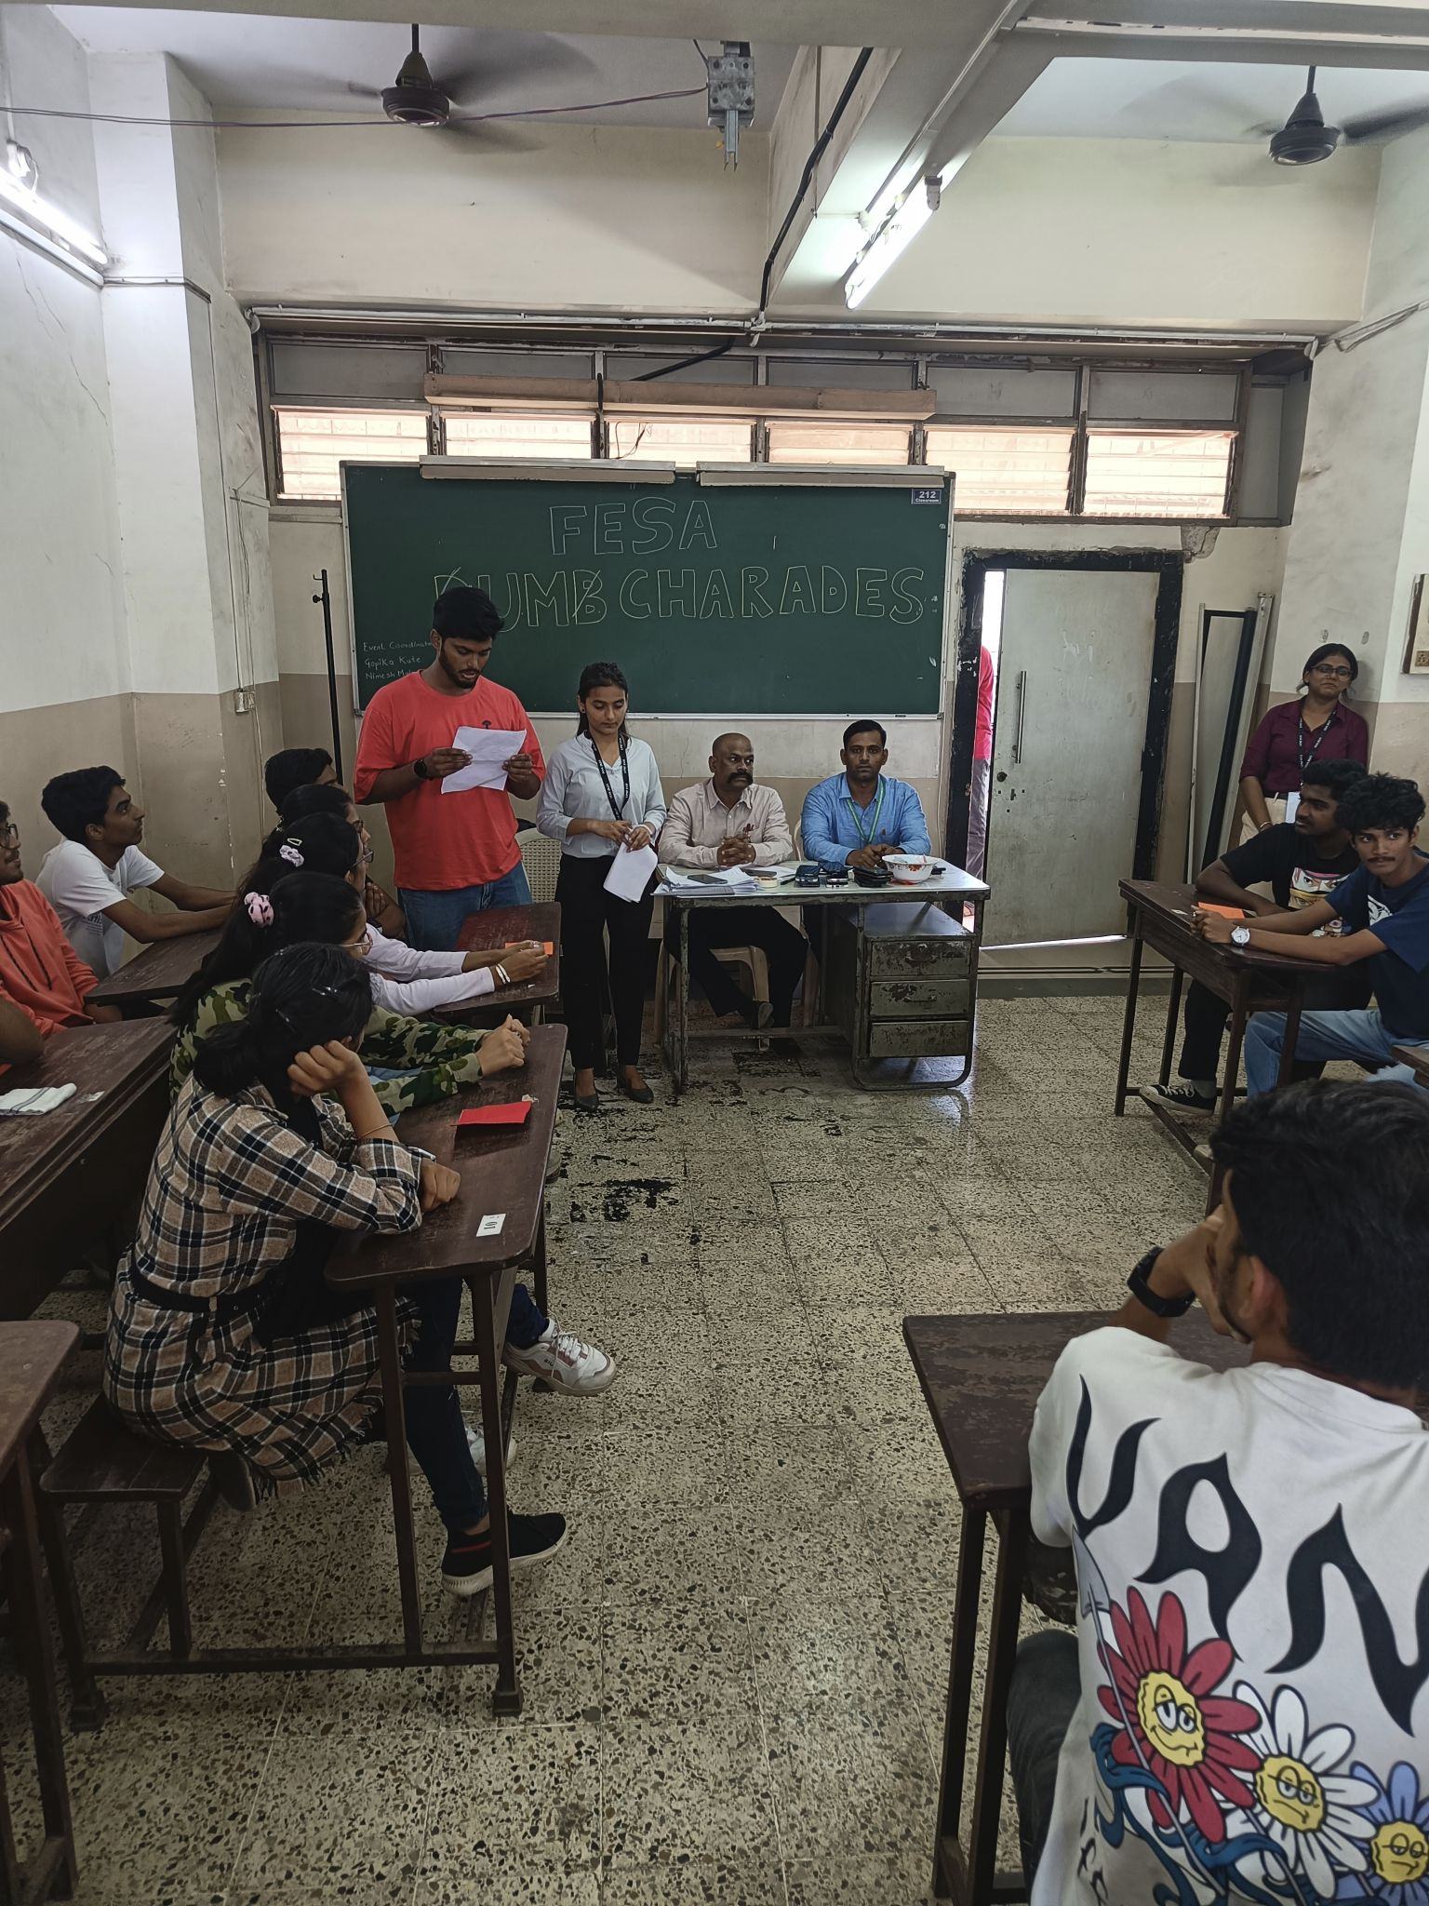
Team Leader | Member 1 | Member 2 | Member 3
Parth Chaugule | Sahil Sawant | Yash Lokare | Atharva Zore
Seeya Kangutkar | Sejal Dongare | Ritesh Parve | Nupur Dhonsekar
Pratik Ohol | Ayush | Pratik | Shreyash
Diksha Jadhav | Soham Gavde | Sarthak Gaikwad | Nutan Avhad
Rushi Sawant | Durvesh Parab | Abhishek Dhumal | Vaishnav Patil
Nashrah Ansari | Rahul Jadhav | Swatantra Kasliwal | Disha Holmukhe

Winner-Parth Chaugule,Sahil Sawant,Yash Lokare,Atharva Zore
Runner Up-Diksha Jadhav,Soham Gavde,Sarthak Gaikwad,Nutan Avhad

Treasure Hunt-
a game in which each person or team attempts to be first in finding something that has been hidden, using written directions or clues.
TEAM NO 1
- Parth Chaugule
- Sahil sawant
- Ranjit patil
- Atharva zore
- Chandresh Alwala
TEAM NO2
- Suyash Garje
- Aniket Wagh
- Om Sutar
- Ishan Armorikar
- Kunal Warang
TEAM NO 3
- Disha Homukhe
- Swatantra Kasliwal
- Rahul Jadhav
- Nashrah Ansari
TEAM NO 4
- Rohan Mhatre
- Siddhesh Narvekar
- Vijay Yadav
- Atharv Kadam
- Vinayak Gorivale
TEAM NO 5
- Komal shelke
- Siddhi jambavdekar
- Shravani khot
- Ansh wagh
TEAM NO 6
- Sejal Dongre
- Seeya kangutkar
- Sachin naik
- Noopur Dhondsekar
TEAM NO 7
- Pranav Molawade
- Prasad Kadam
- Abhijit Shinde
- Ayush morajkar
- Harsh Yadav
TEAM NO 8
- Diksha Jadhav
- Nutan Avhad
- Suyash Patil
- Soham Gawde
- Sarthak Gaikwad
Winner-Team No 4
The program concluded by awarding certificates to the participants by the auspicious hands of dignitaries .
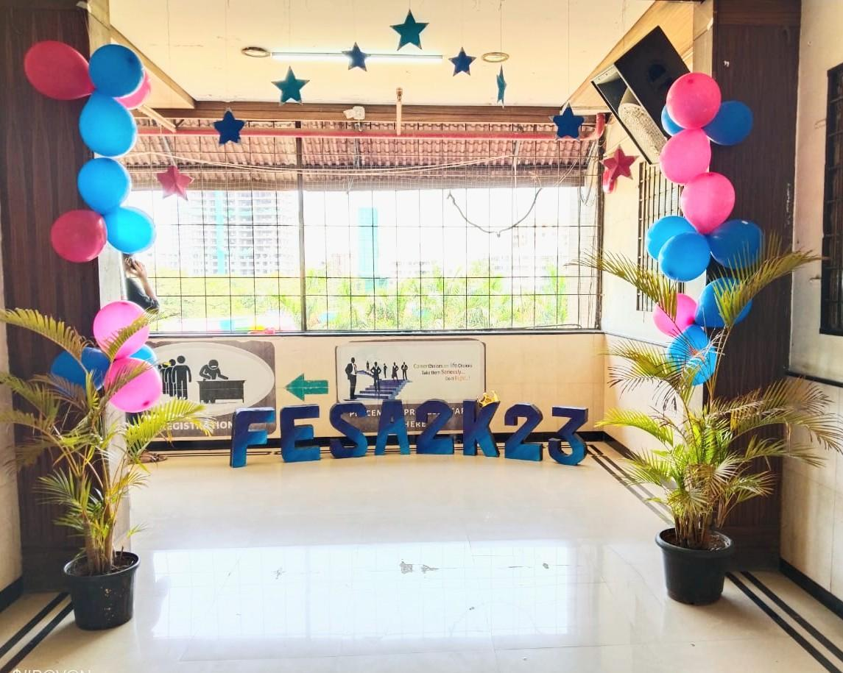

Dr. A. Y. Shete Dr. Alam. N. Shaikh Mr. Manjunath. P. Gawali
[HOD, H & BS] [Principal] [Convener, FESA]

