Prof. Srushti S. Jadhav
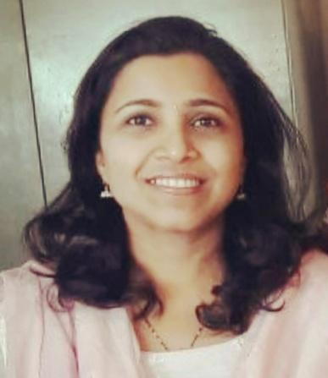
Assistant Professor at Vasantdada Patil Pratishthan’s College of Engineering & Visual Arts
- Department:
COMPUTER ENGINEERING
- Institute:
Vasantdada Patil Pratisthan’s College of Engineering & Visual Arts
- Location:
Sion - Mumbai
- Email Address:
srushtij@pvppcoe.ac.in
Personal Profile :
Introduction:
She works as an Assistant Professor in the department of Computer Engineering. She has contributed in the teaching profession for the last 18 years. She has chosen the profession to get the opportunity every day to inspire, motivate and encourage a young individual to achieve their goals. She is adapted to updating herself with recent technology. She is quick learner, hardworking, sincere , dedicated and honest in her work. She has completed a Masters of Technology in Computer Science Engineering. She has done Bachelors of Engineering in Information Technology from Padmabhushan Vasantdada Patil Pratishthan’s College Of Engineering. She has cleared PET exam for PhD admission and currently pursuing Ph.D in Information Technology from SAKEC, Mumbai University. She has taught subject Data Structures, Database Management System, Analysis of Algorithms for Second Year students, Cryptography & System Security for Third Year students, Computer Simulation & Modeling & Natural Language Processing for Final Year students. She has published 5 papers in the International Conference and 1 paper in National Conference.
Education
- Pursuing Ph.D in Information Technology, Mumbai University
- Master of Technology (M.Tech) in Computer Science Engineering, JNTU University.
- Bachelor of Engineering (B.E.) in Information Technology, Mumbai University.

Professional Experience
- Vasantdada Patil Pratishthan’s College of Engineering & Visual Arts, Assistant Professor (present),2015 till date.
- Manohar Phalke Polytechnic, Sion, HOD(Information Technology Department), 2009 to 2015.
- Manohar Phalke Polytechnic, Sion, Lecturer (Information Technology Department),2004 to 2009.

Courses/ Subject Teaching
- Database Management System
- Data Structures
- Analysis of Algorithms
- Python Programming
- Object Oriented Programming & Methodology
- Computer Simulation & Modeling
- Software Engineering
- Java programming
- Operating System
- Natural Language Processing

STTP/ FDP
- STTP on “Innovative Pedagogical Practices” in July 2023 organized by Vasantdada Patil Pratishthan’s College of Engineering & Visual Arts.
- STTP on “Python Programming for Data Science” in Jan 2023 organized by Vasantdada Patil Pratishthan’s College of Engineering & Visual Arts.
- FDP on “PHP and MySQL” in July 2022 organized by Vasantdada Patil Pratishthan’s College of Engineering & Visual Art
- STTP on “Application of Mathematics in Engineering” in March 2022 organized by Vasantdada Patil Pratishthan’s College of Engineering & Visual Arts.

Research Publications
Research Papers
- Mrs Srushti Jadhav has presented the paper “Evaluating the Resilience of Post-Quantum
Cryptographic Algorithms Against Quantum and Classical Threats” in 16th International Conference on Computing Communication and Networking Technologies (ICCCNT) in 2025.
- Mrs Srushti Jadhav has published the paper “Image Enhancement for Surveillance Videos using Quick Browsing System” in 7th International Conference ICIRTE-2022 in Association with Elsevier.
- Mrs Srushti Jadhav has presented the paper “Redesigning & optimization of conveyor pulley”
” in International Journal of Latest Technology in Engineering, Management & Applied Sciencein 2015.
- Mrs. Srushti Jadhav has presented the paper “Handwritten Character Recognition using Neural Network” in International Conference ICIRTE 2018 (ISSN NO-2349 5162).
- Mrs. Srushti Jadhav has presented the paper “S3^S – A Scalable Shoulder Surfing Resistant” in National Conference MPInnoVision 2013.

