Mr.Amitkumar Khabale
Laboratory Assistant at Vasantdada Patil Pratishthan’s College of Engineering &
Visual Arts.

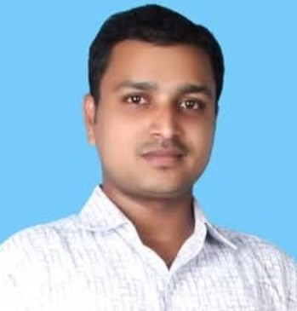

● Department:
COMPUTER SCIENCE ENGINEERING (AIML)
● Institute:
Vasantdada Patil Pratisthan’s College of Engineering & Visual Arts
● Location:
Sion - Mumbai-400022
● Email Address:
amitkhabale@pvppcoe.ac.in

Personal Profile:-
Introduction:-
To want a growth oriented & challenging Career, where I can contribute my knowledge, skills&
Experience to the organization & further enhance my experience through continuous learning &
Team work.
Professional Summary:
Total Experience: 10 Years
Electrical Supervisor: 7 Years
Trainee Engineer: 2 Years
Maintenance Supervisor: 1 Year

➢ Maintenance in All Campus Electrical Supply.
➢ Check all electrical device working Properly.
➢ Do Maintenance and repairing all wiring in campus
➢ Create a new Computer labs.
➢ Take a reading of Solar Panel
➢ Do Cleaning and clear the fault in Solar Panel
➢ Check all Billing and contact with MSEB.
➢ handling The Shop-floor Machine Maintenance
➢ Handling the PM Activity
➢ All Mechanical & Electrical & Electronics Machine Maintenance
➢ working on UPS supply, Non UPS Supply, Maintain Generator, Check AC Supply.
➢ checking the whole control Panel & Distribution & Transmission Supply. )
➢ 2 &4 Wheller Machines including:-Calibration Machine ,Vaibration Machine ,Super
Control, Fire wall, Preventive , Predictive , Brake Down & Plan Maintenance of all Machine’s.
Work Summary:
(1) PVPPCOE, Sion From August 2025 to Till Date
Post: Electrical Supervisor
➢ PVPP is big campus of Engineering, Law & Fine Arts, Architecture College.
➢ Do all wiring and do maintenance in whole campus
➢ Check all connections and repairing work
➢ Co-ordinate with MSEB. For Billing
➢ Handling Solar Panel Take a Reading, Cleaning & Resolving Fault.
➢ Maintain Generator & Transmission Supply. Check a Power Distrubution.
➢ Check LAN, Telephonic and Internet Connection in Whole Campus.
➢ Make all computer Lab connection, AC Connection
➢ Arrange Auditorium for all functions.
➢ Helps to make a good support for all functions Lighting.
➢ Handling all Electronics labs and Maintenance all the device.

