Mrs. Heena Shaikh
Laboratory Assistant at Vasantdada Patil Pratishthan’s College of Engineering & Visual Arts.
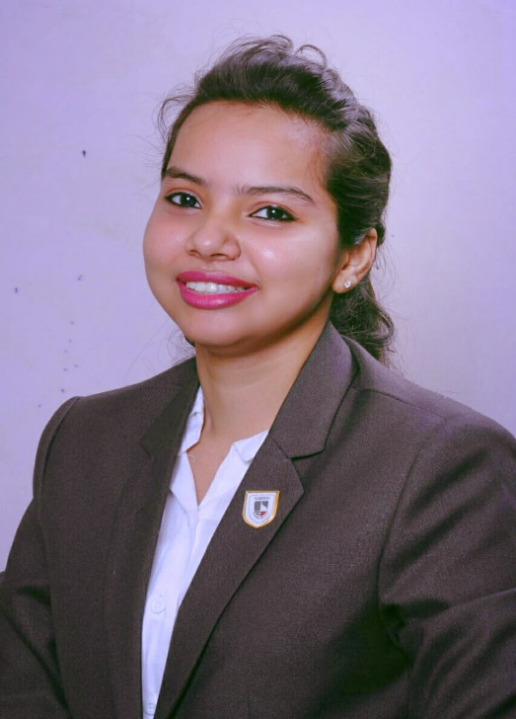

- Department:
COMPUTER SCIENCE ENGINEERING (AIML)
- Institute:
Vasantdada Patil Pratisthan’s College of Engineering & Visual Arts
- Location:
Sion - Mumbai-400022
- Email Address: skheena@pvppcoe.ac.in

Personal Profile Introduction
she works as an Assistant Professor in the Department of Computer Science Engineering. With five years of dedicated experience as an Assistant Professor in an engineering college, she teaches and mentor students in programming languages (C, C++, Java) and core systems subjects (DBMS, SQAT, ED, COA). She is design and deliver comprehensive lectures, hands‑on lab sessions, and assessments that bridge theoretical knowledge with practical application. Her teaching strategy integrates interactive learning techniques, real-world project assignments, and continuous feedback to strengthen student engagement. She actively mentor students in academic planning, project innovation, and ethical professional development to prepare them for both advanced studies and industry roles.
As the Training & Placement In‑Charge for the AI/ML department, she coordinates student training sessions, soft skill development, and placement initiatives tailored to emerging industry trends. She organizes department-level seminars, workshops, and mock interviews in collaboration with industry professionals and alumni to boost students’ readiness. She facilitates internship placements, campus recruitment drives, and industry partnerships, ensuring robust opportunities for students’ career growth.
Her interdisciplinary approach connects foundational subjects with AI/ML trends, empowering students to adapt and excel in evolving tech landscapes.
Passionate about academia-industry integration, she is committed to nurturing student success through innovative teaching, comprehensive mentoring, and strategic placement leadership.

Current Job specifications: -

Assistance Professor

TPO In-charge of the department

Education
  - Bachelor of Engineering in Information Technology from PVPPCOE, Mumbai.
  - Master of technology in Computer/ Information Technology from NMIMS, Mumbai.

Professional Experience
  - Worked as an Assistance professor at NMIMS, Mumbai.
  - Content writer for academic
  - Mentor and Counselor

