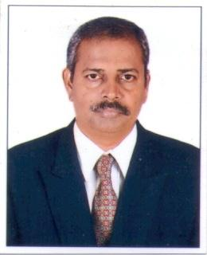

Mr. Shankar P. Mane
Department:- Artificial Intelligence and Data Science
Email ID:- smane@pvppcoe.ac.in
Introduction:-
Presently he works as a Sr. Technical Assistant in Department of Computer Science & Engineering (AIML). Previously he has also worked in Electronics Engineering Department. He has contributed himself in the technical profession for the last 21 years. He has knowledge of Electronic Laboratory Equipments, Software installation & troubleshooting of PC.
He works hard for the betterment of the institute. He believes in quality education and he is very dedicated towards his work.

Current Job specifications:-
- Software Installation, troubleshoots and diagnoses basic problems with Computer and peripherals. Performs minor maintenance and repair as necessary.
- Record keeping related to Lab documents such as Dead Stock Register, Inward outward Register, Consumable Register, Attendance Register, Maintenance Register, and Printing Record Register.
- Assist Teaching Faculty to conduct Practical and to make Laboratory Manuals.
- Assists students in their Practical & Project work.
- Work as Understudy Supervisor in Exam section to conduct University Examination

Education:-
- Diploma in Electronics & Communication Engineering from MSBTE Mumbai.

Professional Experience:-

Industrial Experience : 2 Years
VPPCOE & VA : Since September 2002

Other Courses / Training Programmes
- One Week AICTE-ISTE approved workshop on “Soft skill, Advance MS-Excel, PC & Network Components Awareness & it’s Troubleshooting” organized by VPPCOE & VA Sion, Mumbai-22 during 2nd January, 2023 to 6th January,2023
- One Week Workshop on “PC Hardware, Advance MS Excel and Soft Skill Development” organized by PVPPCOE from 1st January 2019 to 5th January 2019.
- ISTE approved One Week STTP on, “PC assembling, Networking and Circuit Board Overview” organized by PVPPCOE from 2nd January 2018 to 6th January 2018.
- IETE approved three days Workshop with Hands on Training on, “ Basic & Recent Trends in Electronics based Laboratories” at PVPP’s College of Engineering, Mumbai during 28th-30th June 2017.
- Three days Workshop on, “RF, Microwave Fundamentals & Hands on Training” at PVPP’s College of Engineering, organized by Electronics and EXTC Departments from 4th July to 7th July, 2016.
- One Week Training Program on “ Maintenance of Electronic Laboratory Equipments” Jointly conducted by Vidyalankar Institute of Technology and Western Regional Instrumentation Centre (WRIC) from 8th July to 12 July, 2013.
- ISTE Approved Three days Workshop on, “NEXT GENERATION NETWORKS” held at PVPPCOE, Sion, Mumbai. From 21st Feb to 23rd Feb, 2008.

