Mr.Vinayak Tatoba Shidruk
Laboratory Assistant at Vasantdada Patil Pratishthan’s College of Engineering & Visual Arts.
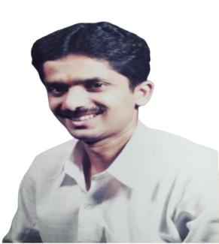
● Department: COMPUTER SCIENCE ENGINEERING (AIML)
● Institute: Vasantdada Patil Pratisthan’s College of Engineering & Visual Arts
● Location: Sion - Mumbai-400022
● Email Address:
vinayaks@pvppcoe.ac.in

Personal Profile
Introduction:-
He is working in Institute since October 2002 He is currently working as a Senior Technical Assistant in Computer Science engineering (AIML) department. He had also worked in Manohar Phalke Polytechnic and Electronics & Telecommunication Department. He has contributed himself in the technical profession for the last 23 years. He has knowledge of Software installation & troubleshooting of PC.

He has completed a B.sc (Chemistry) from Shivaji University Kolhapur. He has also done PG Diploma in Analytical chemistry.

He works hard for the betterment of the institute. He believes in quality education and he is very dedicated towards his work.

Current Job specifications:-
1. Software Installation troubleshoots and diagnoses basic problems with Computer and peripherals. Performs minor maintenance and repair as necessary.
2. Record keeping related to Lab documents such as Dead Stock Register, Inward outward Register, Consumable Register, Attendance Register, Maintenance Register, and Printing Record Register.
3. Periodically report generation on Lab requirement and Lab status.
4. Implementation of resource sharing in Network such as Network printer, Scanner, CD/DVD ROM.
5. Assist Teaching Faculty to conduct Practical and to make Laboratory Manuals.
6. Assists students in their Practical & Project work. 7. Work as Understudy Supervisor in Exam section to conduct Class Test & University Examination
Education
● B.Sc (Chemistry) Shivaji University Kolhapur.
● PG Diploma in Analytical chemistry.
Professional Experience
● 13 years Experience in “Manohar Phalke Polytechnic
Sion”as a “Lab Assistant” in Electronics Department.
● Currently Working in “Vasantdada Patil Pratishthan‘s
College of Engineering & Visual Arts “sion as a “Sr Tech Asst.” in Computer Science engineering (AIML).

