Prof. Devita Sudhir Ghanekar
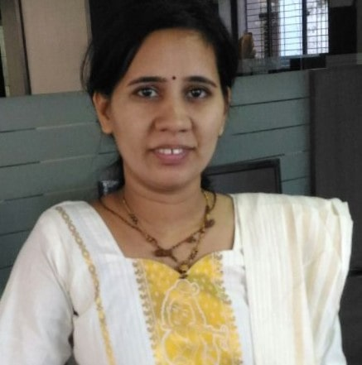

Assistant Professor at Vasantdada Patil Pratishthan’s College of Engineering & Visual Arts
- Department:
CS (AIML)
- Institute:
Vasantdada Patil Pratisthan’s College of Engineering & Visual Arts
- Location:
Sion - Mumbai
- Email Address:
devitaghanekar@pvppcoe.ac.in
Personal Profile :
Introduction:

She works as an Assistant Professor in the department of Computer Science & Engineering (AI & ML).
She has contributed in the teaching profession for the last 15 years. She has chosen the profession to get the opportunity every day to inspire, motivate and encourage a young individual to achieve their goals. She is adapted to updating herself with recent technology. She is quick learner, hardworking, sincere , dedicated and honest in her work. She has completed a Masters of Technology in Computer Science Engineering from PHCET, Rasayani. She has done Bachelors of Engineering in Information Technology from Bharati Vidyapeeth College Of Engineering, Kharghar. She currently pursuing Ph.D in Computer Engineering from VJTI, Mumbai University. She has taught subject Open Elective- Logic and Data Interpretation, Database Management System for Second Year students, Data Analytics and Visualization , Skill lab AWS for Third Year students, Blockchain Technology for Final Year students. She has published 3 papers in the UGC approve journal.
Education
- Pursuing Ph.D in Computer Engineering, Mumbai University
- Master of Engineering in Computer Engineering, Mumbai University.
- Bachelor of Engineering (B.E.) in Information Technology, Mumbai University.

Professional Experience
- Vasantdada Patil Pratishthan’s College of Engineering & Visual Arts, Assistant Professor (present),2024 till date.
- Transstadia Institute, Kalina Campus, Mumbai University(1 August 2023 to July 2024)
- Lokmanya Tilak College of Engineering, Koparkhairane, Navi Mumbai(22 Dec 2022 to 28 July 2023)
- Shivaji Rao Jondhale College of Engineering, Dombivali, (2 July, 2016 to 20 Dec 2022)
- Pillai HOC College of Engineering and Technology College, Rasayani, Raigad.(3 Years 6 month)

Courses/ Subject Teaching
- Database Management System
- Python Programming
- Data Analytics and Visualization
- Automata Theory
- Software Engineering
- Skill lab- AWS
- C Programming
- Blockchain Technology

STTP/ FDP
- FDP on “QT-02 Foundation of Quantum Technologies ” in Sept 19 – Oct 2025 organized by EICT Academy, MNIT Jaipur
- FDP on “QT-06 Quantum Communication ” in Aug 18 – Sept 11 2025 organized by EICT Academy, MNIT Jaipur
- FDP on “QT-07 Quantum Sensing ” in Sept 26 – Oct 17 2025 organized by EICT Academy, MNIT Jaipur
- NPTEL Introduction to Quantum Computing: Quantum Algorithms and Qiskit Successul Completed.

Research Publications
Research Papers
- Student Performance Analysis System,JETIR, Volume7 Issue 9, September-2020, eISSN: 2349-5162.
- Blockchain Based E-voting System Using Smart Contracts, ISSN : 2321-9653, Publisher Name : IJRASE
- MapReduce Architecture for Reality Mining of Urban Space, Conference: Tech Streams National Conference At: Pilli HOC College of Engineering& Technology, Rasayani

